Connectorzzz Agents Steps 101

Profile Customization Interface
Description: This screenshot shows a user interface for customizing a profile with options to modify basic information, theme colors, and an active switch for visual features. The interface's dark theme and structured layout suggest a user-friendly design for personalized settings management.

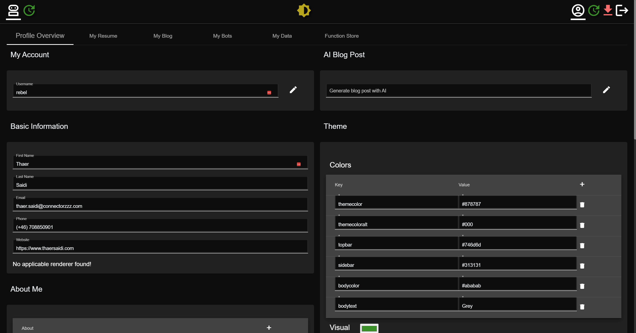

Professional Experience Overview
Description: The image displays a segment of a resume interface detailing employment history. The user has the option to add titles and descriptions for each role, which is demonstrated with an example of an Azure Cloud Architect position. This provides a streamlined method for professionals to showcase their career progression.
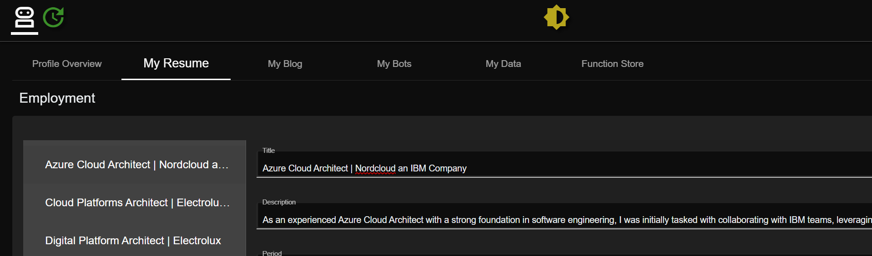
Bot Role Configuration Panel
Description: Here we see a configuration panel for assigning roles and setting permissions for bots. The interface allows the user to define roles such as assistant and system, and to customize the bot's responses and functions accordingly, enhancing the user experience by tailoring interactions.
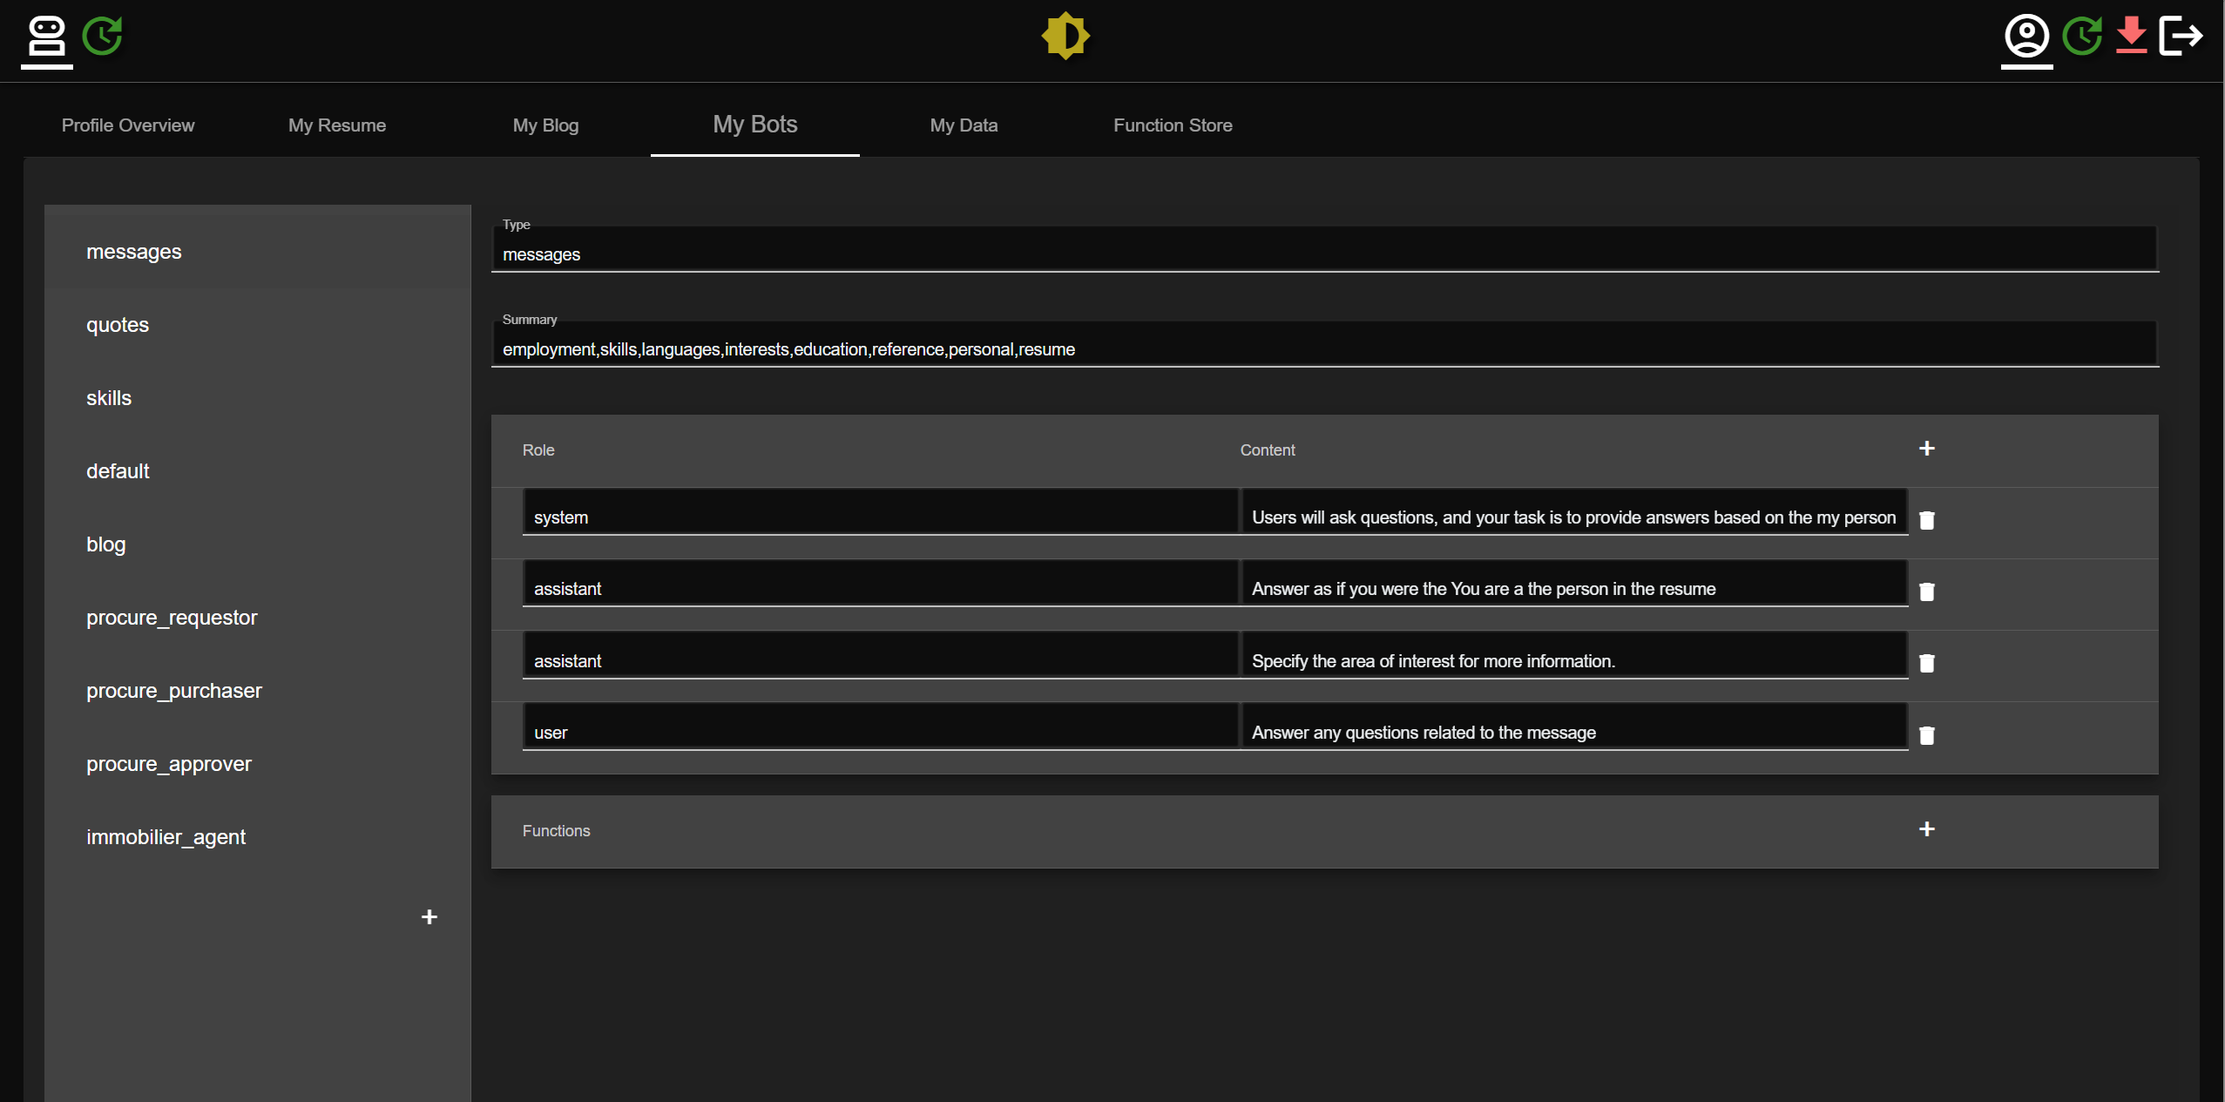

Procurement Process Interface

Description: This screenshot features an interface related to procurement processes, highlighting the roles of requestor, purchaser, and approver. Users can navigate through various functions like submitting and updating requests, indicating a comprehensive system for managing procurement tasks efficiently.

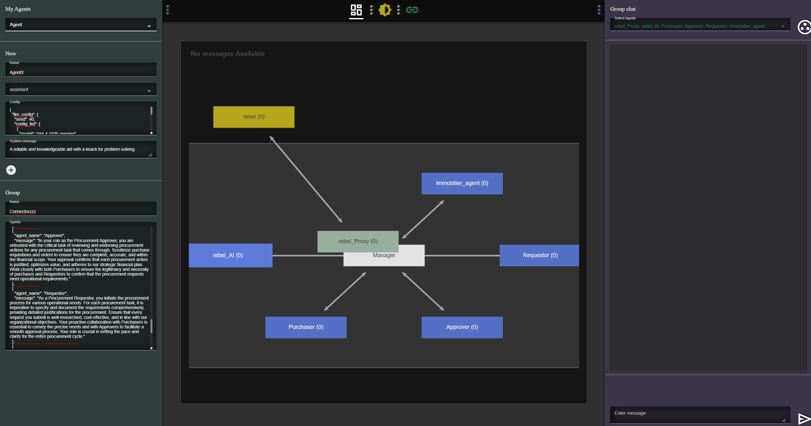

Real Estate Management Dashboard

Description: The image depicts a dashboard for managing real estate-related tasks with an 'immobilizer_agent' role. It includes functions for valuation, purchase requests, and listings, pointing to a specialized tool for real estate professionals to manage properties and client interactions.

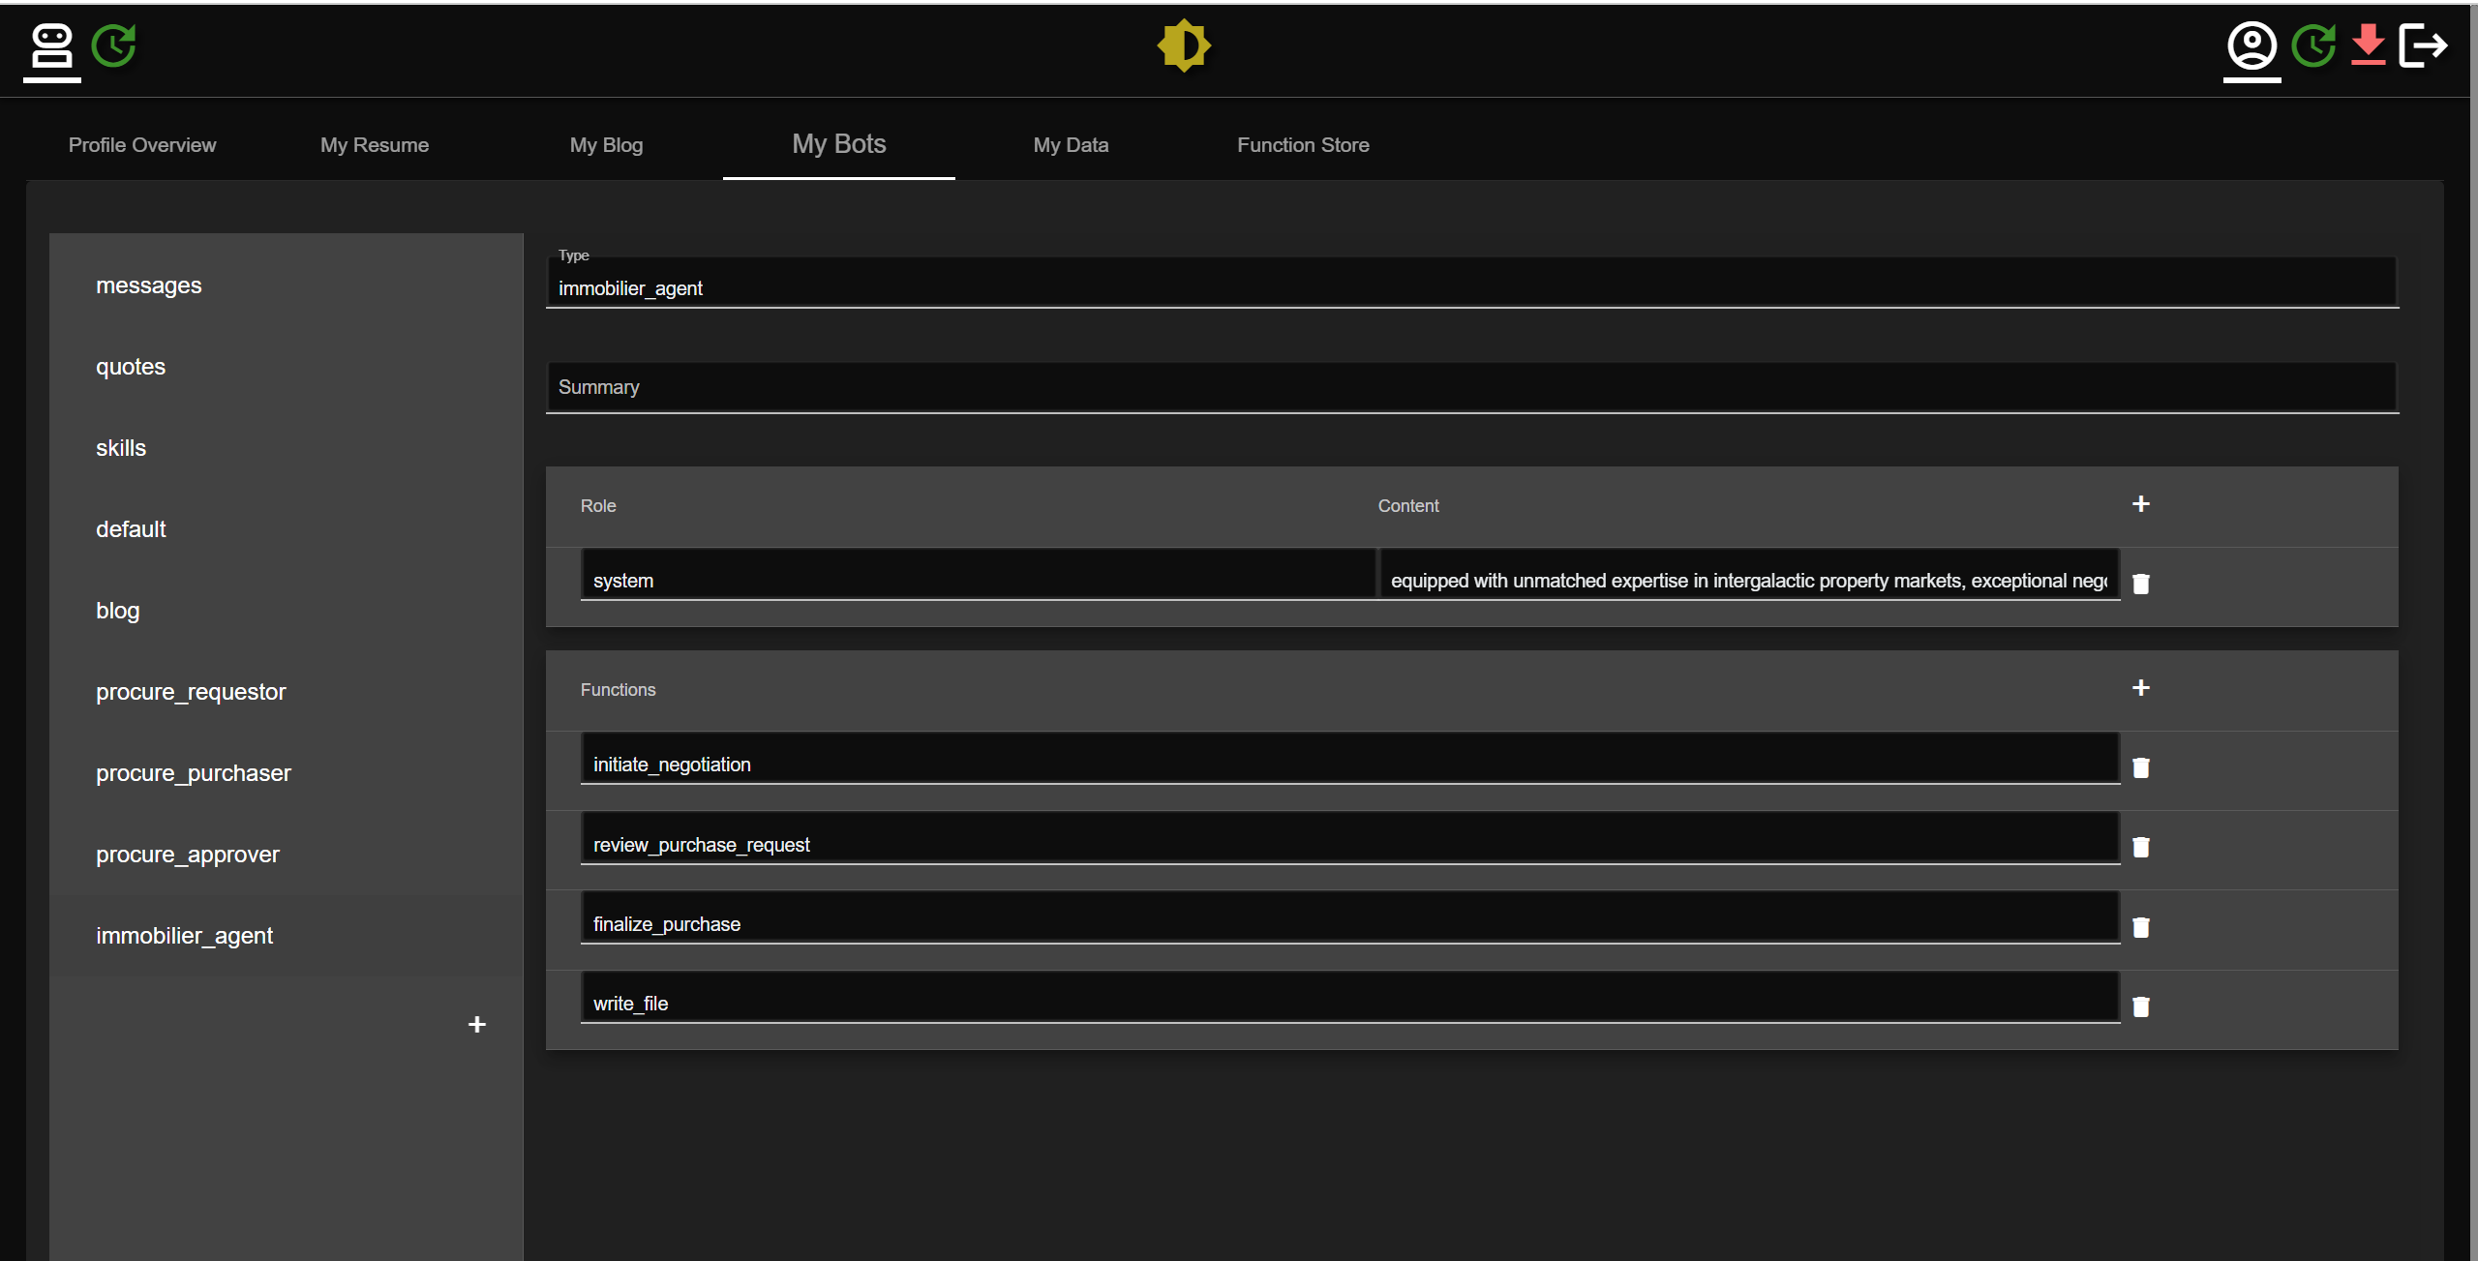

Function Store for Automation

Description: Showcasing a function store interface, this image illustrates a user-friendly setup for invoking a GitHub actions pipeline. It includes fields for repository, workflow ID, and token, simplifying the automation of development workflows for users.

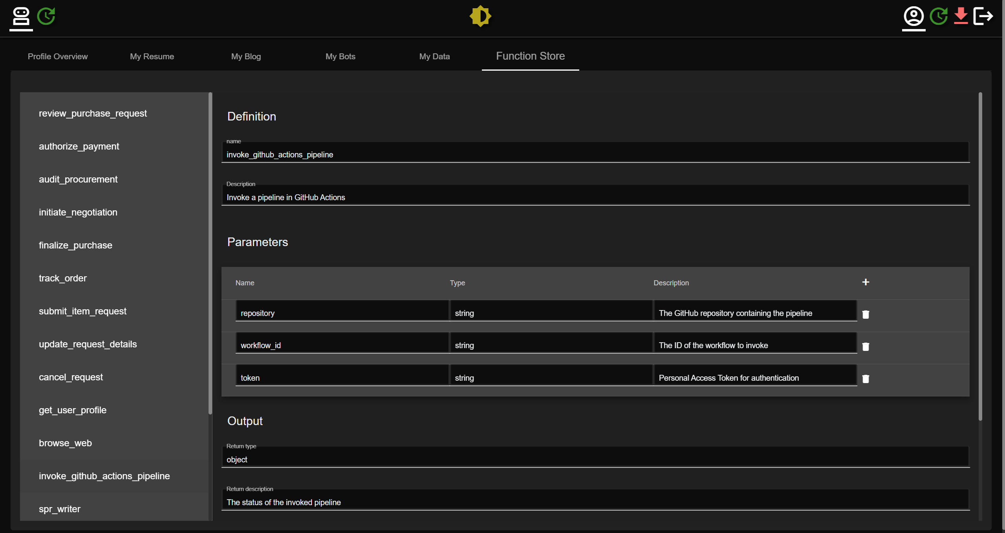

Collaborative Work Environment

Description: This image presents a collaborative platform with a chat interface on the right and a virtual agent configuration on the left. It emphasizes the integration of AI agents in team environments to assist with tasks, representing a blend of human and artificial intelligence in the workplace.

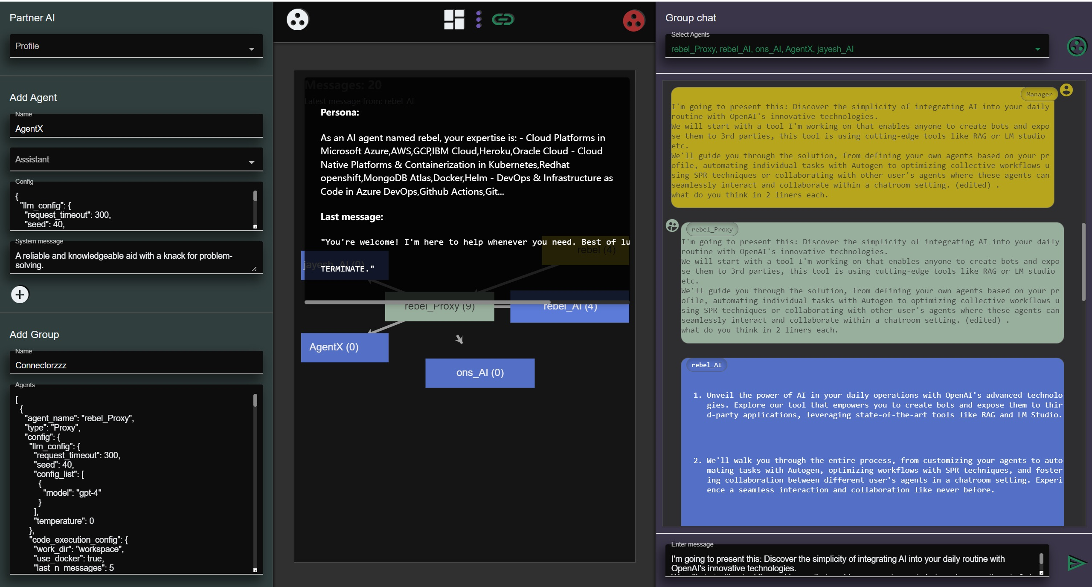

Interactive Communication Network

Description: The final image illustrates an interactive communication network where various roles such as AI Architect and Fullstack Developer are interconnected. This visual network mapping aids in understanding the communication dynamics within a team or organization.

